**Usman Institute of Technology**

Introduction to Database Systems (CS311)

**Course Project**

Software Engineering Section <A>

<EMPLOYEE ATTENDANCE MANAGEMENT SYSTEM>

Part 4

**Question:** Power Point Presentation and Demonstration Video

1. Prepare power point presentation.

File is attached on teams

1. Demonstrate your course project in detail.

I already demonstrated our project in video but here I am going to tell you what our project basically do….

Out project (employee management system) basically is a project design to mark the attendance of the employees by the admin or HOD. Only the admin have access to the software he have username and password which we describe or set in the source code there are only 3 admins only they can access to the software while entering username and password once he enter correct username and password he will be able to add employee delete update or see employees list also he will have access to add, remove, upgrade, list all the department and shifts main purpose of the software is to mark the attendance of the employees what our software basically do. An admin can mark the attendance of the employees by entering date employee number and status of attendance in the attendance frame the status must be in present, absent, leave which we set in our database after marking the attendance the admin can also view the attendance of all the employees date wise. That’s all what the software demanded and we fulfil the need or our customer. Not only this we also provide an additional option if the admin decided to provide the software to the employees they can also view their entire attendance status (we already described the whole functionality of software in our PPT and video)

1. Draw System flow diagram.

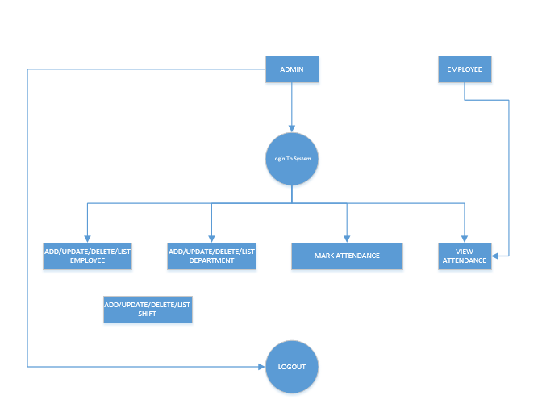

1. Draw Class diagram of your project.

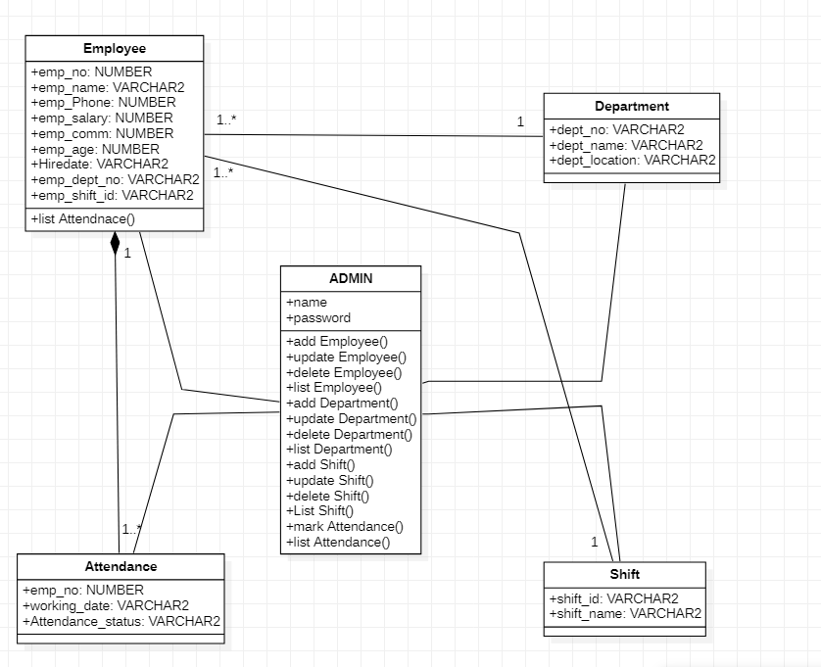

1. Draw Entity Relationship diagram.

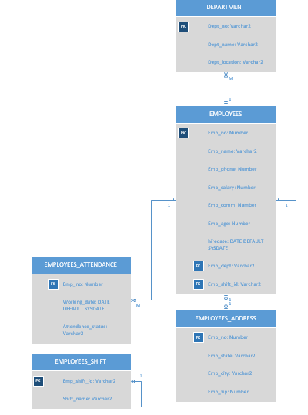

1. Draw Enhanced Entity Relationship diagram.
2. Prepare video with voice over to show the working of your application.

Video is attached on teams

1. Upload your complete project in .zip file. Also include readme file for installation and usage.

File is attached on teams

**Note:** Attached all files including MS Visio, SQL scripts, MS Word, Video etc.

**Question:**

Write a python script which will do the following tasks.

1. Read excel sheet (all sheets) from MS Excel file.
2. Prepare separate tables for each Excel sheet.
3. Use first row of sheet as table attributes.
4. And use rest of the rows (in excel sheet) as data into table as records (rows).

**Note**: Test your program and make sure that your program must be able to

**INPUT**: Read from Excel file (all sheets e.g sheet1, sheet2 etc.).

**Output**: ORACLE SQL script that can be use to create schema (all tables with data

inserted).

excel2schema <*filename.xlsx*>

